|  |  |  |  |  |
| --- | --- | --- | --- | --- |
| **Name** | **Type** | **Value** | **Scope** | **Usage** |
| Marks | Integer  (+ or – whole numbers) | 65 | Local   * Only the declared module / program can access | Variable   * Can change the value during the execution of the program |
| Average | Real  (+ or – fractional numbers) | 58.325 | Global   * All the modules / programs can access | Constant   * Fixed value that cannot change during the execution of the program |
| Address | String  (a chain of characters) | “No 25, Visakha Road, Colombo” | Partially Global   * Some modules / programs can access |  |
| Gender | Char  (a single character) | ‘M’ , ‘F’ |  |  |
| Married | Boolean  (Gate switches) | True, False |  |  |

**DATA**

1. **Write a pseudocode for a program to calculate and display the total of two marks obtained from the user.**

Program FindTotal

Local Data

Mrk1 , Mrk2, Total : Integer

Begin

Display “Enter Mark 1: “

Input Mrk1

Display “Enter Mark 2: “

Input Mrk2

Total = Mrk1 + Mrk2

Display “Total Marks : “ , Total

End

End FindTotal

1. **Write a pseudocode to input marks of three subjects from the keyboard and calculate and display the total and average of the marks on the screen.**

Program FindTotal&Average

Local Data

Mrk1 , Mrk2, Mrk3, Total : Integer

Avg : Real

Begin

Display “Enter Mark 1: “

Input Mrk1

Display “Enter Mark 2: “

Input Mrk2

Display “Enter Mark 3: “

Input Mrk3

Total = Mrk1 + Mrk2 + Mrk3

Avg = Total / 3

Display “Total Marks : “ , Total

Display “Average Marks : “ , Avg

End

End FindTotal

1. **Write a pseudocode for a program to obtain the marks from the user and display the grade.**

**Grade. Marks >= 50 : “Pass”**

**Marks < 50 : “Fail”**

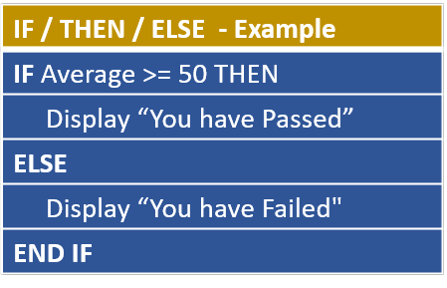

Program FindGrade

Local Data

Mrk : Integer

Grd : String

Begin

Display “Enter Marks : “

Input Mrk

IF Mrk >= 50 THEN

Grd = “Pass”

ELSE

Grd = “Fail”

END IF

Display “Grade : “ , Grd

End

End FindGrade

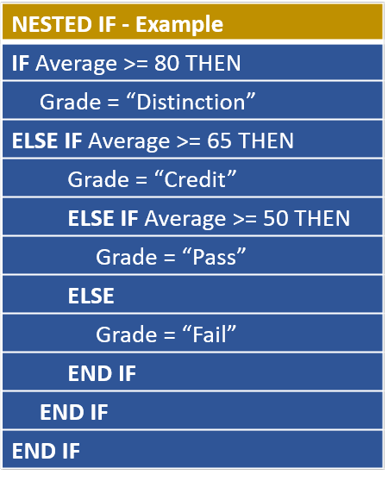

**IF Average >= 80 THEN**

**Grade = “Distinction”**

**ELSE**

**IF Average >= 65 THEN**

**Grade = “Credit”**

**ELSE**

**IF Average >= 50 THEN**

**Grade = “Pass”**

**ELSE**

**Grade = “Fail”**

**END IF**

**END IF**

**END IF**

1. **Write a pseudocode for a program to obtain the marks from the user and display the grade.**

|  |  |
| --- | --- |
| **Marks** | **Grade** |
| Marks >= 80 | **“**A” |
| Marks >= 60 | “B” |
| Marks >= 50 | “C” |
| Marks > = 40 | “D” |
| Marks < 40 | “F” |

Program FindGrade

Local Data

mrk : Integer

grd : char

Begin

Display “Enter Marks:”

Input mrk

IF mrk >= 80 THEN

grd = ‘A’

ELSE IF mrk >= 60 THEN

grd = ‘B’

ELSE IF mrk >= 50 THEN

grd = ‘C’

ELSE IF mrk >= 40 THEN

grd = ‘D’

ELSE

grd = ‘F’

END IF

END IF

END IF

END IF

Display “Grade : “ , grd

End

End FindGrade

1. **Write a pseudocode for a program to obtain marks of three subjects from the user as input and find the highest mark out of the three and display it as a result on the screen.**

Program HighestMark

Local Data

Mrk1, Mrk2, Mrk3, High , Highest: Integer

Begin

Display “Enter Mark 1: “

Input Mrk1

Display “Enter Mark 2: “

Input Mrk2

Display “Enter Mark 3: “

Input Mrk3

IF Mrk1 > Mrk2 THEN

High = Mrk1

ELSE

High = Mrk2

END IF

IF High > Mrk3 THEN

Highest = High

ELSE

Highest = Mrk3

END IF

Display “Highest Mark: “ , Highest

End

End HighestMark

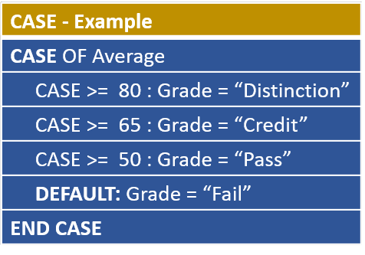

CASE OF mrk

80..100 : Grade = “Distinction”

65..79 : Grade = “Credit”

50..64 : Grade = “Pass”

DEFAULT : Grade = “Fail”

END CASE

1. **Write a pseudocode for a program to perform the operations of a basic calculator. Obtain two values and the necessary operator from the user and perform the necessary function to the two values accordingly and display the final answer.**

**Operators : ‘+’ , ‘-‘ , ‘*’ , ‘/’**

**If an invalid operator is given by the user, it should display “Invalid Operator”.**

Program BasicCalculator

Local Data

Val1, Val2 : Integer

Opr : Char

Begin

Display “Enter Value 1: “

Input Val1

Display “Enter Value 2: “

Input Val2

Display “Enter your operator: “

Input Opr

IF Opr = ‘+’ THEN

Display “Answer: “ , Val1+Val2

ELSE IF Opr = ‘-‘ THEN

Display “Answer: “ , Val1-Val2

ELSE IF Opr = ‘*’ THEN

Display “Answer: “ , Val1*Val2

ELSE IF Opr = ‘/’ THEN

Display “Answer: “ , Val1/Val2

ELSE

Display “Invalid Operator”

END IF

END IF

END IF

END IF

End

End BasicCalculator

Program BasicCalculator

Local Data

Val1, Val2 : Integer

Opr : Char

Begin

Display “Enter Value 1: “

Input Val1

Display “Enter Value 2: “

Input Val2

Display “Enter your operator: “

Input Opr

CASE OF Opr

‘+’ : Display “Answer: “ , Val1+Val2

‘-‘ : Display “Answer: “ , Val1-Val2

‘*’ : Display “Answer: “ , Val1*Val2

‘/’ : Display “Answer: “ , Val1/Val2

DEFAULT : Display “Invalid Operator”

END CASE

End

End BasicCalculator

**Operators and Operands**

A = B + C

Operators 🡪 = , +

Operands 🡪 A , B , C

1. **Assignment Operator**

, =

A 10 , A = 10

1. **Arithmetic Operators**

|  |  |
| --- | --- |
| **Operator** | **Example** |
| + | 10 + 3 = 13 |
|  | 10 – 3 = 7 |
| * | 5 * 3 = 15 |
| / | 10 / 3 = 3.33 |
| MOD | 10 MOD 3 = 1 |
| DIV | 10 DIV 3 = 3 |

DIV 🡪 Integer Division MOD 🡪 Remainder of Integer Division

1. **Comparison Operators**

|  |  |
| --- | --- |
| = | Equal |
| < > | Not Equal |
| > | Greater than |
| >= | Greater than or equal |
| < | Less than |
| <= | Less than or equal |

1. **Logical Operators**

AND

OR

XOR

NOT

|  |  |  |
| --- | --- | --- |
| **(A > B) AND (B > C)** | | **Result** |
| T | T | T |
| T | F | F |
| F | T | F |
| F | F | F |

|  |  |  |
| --- | --- | --- |
| **(A > B) OR (B > C)** | | **Result** |
| T | T | T |
| T | F | T |
| F | T | T |
| F | F | F |

|  |  |  |
| --- | --- | --- |
| **(A > B) XOR (B > C)** | | **Result** |
| T | T | F |
| T | F | T |
| F | T | T |
| F | F | F |

**NOT**

! ( A > B ) = (A < = B )

**3) Repetition / Iteration**

**While Loop**

1. **Write a pseudocode for a program to display the numbers from 1 to 5.**

Program Display1to5

Local Data

n : Integer

Begin

n = 1

WHILE (n <= 5) DO

Display “Value of n: “ , n

n = n + 1

END WHILE

End

End Display1to5

1. **Write a pseudocode for a program to display the numbers from 5 to 1.**

Program Display5to1

Local Data

n : Integer

Begin

n = 5

WHILE (n >= 1) DO

Display “Value of n: “ , n

n = n - 1

END WHILE

End

End Display5to1

**Repeat / Until Loop**

1. **Write a pseudocode for a program to display the numbers from 1 to 5.**

Program Display1to5

Local Data

n : Integer

Begin

n = 1

REPEAT

Display “Value of n: “, n

n = n + 1

UNTIL (n > 5)

End

End Display1to5

1. **Write a pseudocode for a program to display the numbers from 5 to 1.**

Program Display5to1

Local Data

n : Integer

Begin

n = 5

REPEAT

Display “Value of n: “, n

n = n - 1

UNTIL (n < 1)

End

End Display5to1

**For Loop**

**7. Write a pseudocode for a program to display the numbers from 1 to 5.**

Program Display1to5

Local Data

n : Integer

Begin

FOR (n = 1, n <= 5, n++)

Display “Value of n: “, n

END FOR

End

End Display1to5

**n = n + 1 🡪 n++ 🡪 n += 1**

**n = n – 1 🡪 n-- 🡪 n -= 1**



**FOR (n = 1, n <= 5, n++)**



**Display “Value of n: “, n**



**END FOR**



**8.Write a pseudocode for a program to display the numbers from 5 to 1.**

Program Display5to1

Local Data

n : Integer

Begin

FOR (n = 5, n >= 1, n--)

Display “Value of n: “, n

END FOR

End

End Display5to1

1. **Write a pseudocode for a program that display the sum of all values, sum of odd values and sum of even values between 1 to 10.**

Program sumOddEven

Local Data

x, sumAll, sumOdd, sumEven : Integers

Begin

sumAll, sumOdd, sumEven = 0

FOR (x = 1, x <= 10, x ++)

sumAll = sumAll + x

IF (x MOD 2 = 0) THEN

sumEven = sumEven + x

ELSE

sumOdd = sumOdd + x

END IF

END FOR

Display “Sum of All Numbers :”, sumAll

Display “Sum of Even Numbers :”, sumEven

Display “Sum of Odd Numbers :”, sumOdd

End

End sumOddEven

1. **Write a pseudocode for a program to get the marks of 10 students and display the total and average of the marks.**

Program TotAndAvg

Local Data

mrk, tot, x : Integer

avg : Real

Begin

tot = 0

FOR ( x = 1, x <= 10, x++)

Display “Enter marks :”

Input mrk

tot = tot + mrk

END FOR

avg = tot / 10

Display “Total Marks :”, tot

Display “Average Marks :”, avg

End

End TotAndAvg

1. **Write a pseudocode for a program to calculate the factorial of a given value.**

**Example : Factorial of 5 = 5 x 4 x 3 x 2 x 1 = 120**

**Factorial of 4 = 4 x 3 x 2 x 1 = 24**

**Factorial of 3 = 3 x 2 x 1 = 6**

**Factorial of 2 = 2 x 1 = 2**

**Factorial of 1 = 1**

Program Factorial

Local Data

n, fact : Integer

Begin

Display “Enter a positive integer:”

Input n

fact = 1

WHILE (n > 1) DO

fact = fact * n

n = n – 1

END WHILE

Display “Factorial Value :”, fact

End

End Factorial

1. **Write a pseudocode for a program to output the following pattern after obtaining the number of lines from the user.**

**\***

**\*\***

Program Pattern

Local Data

n, x, y : Integer

Begin

Display “Enter number of Lines:”

Input n

FOR (x = 1, x <= n, x++)

FOR (y = 1, y <= x, y++)

Display “*”

END FOR

GOTO New Line

END FOR

End

End Pattern

|  |  |  |
| --- | --- | --- |
| **While Loop** | **Repeat / Until Loop** | **For Loop** |
|  |  |  |
|  |  |  |
|  |  |  |
|  |  |  |
|  |  |  |